Record of evidence mapping applicant’s knowledge and understanding for the ABTC standard for Animal Behaviour Technician
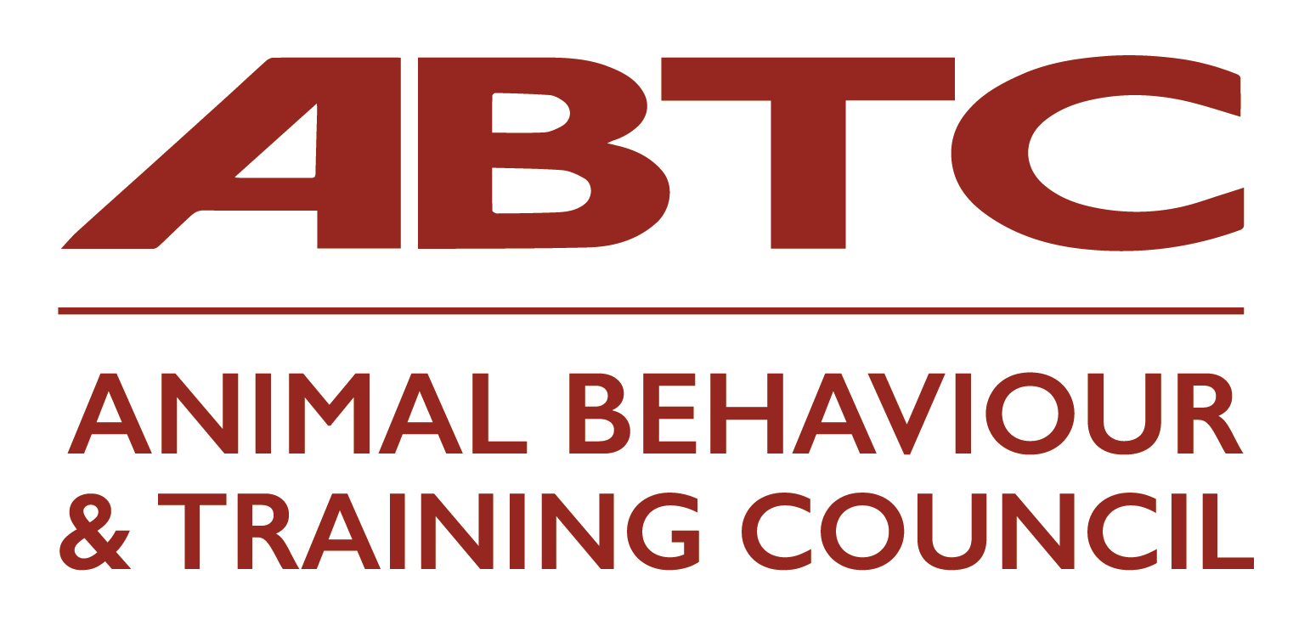
Name of Applicant:
Please refer to the ABTC Guidelines and the ABTC standards prior to completing this form.
Please refer also to the Reflective Accounts Form – one form for each section of Knowledge and Understanding
Overview: ABTC Standard - Animal Behaviour Technician
This ABTC Standard relates to the design and implementation of programmes to provide preventative and first-aid behavioural advice to owners/handlers and/or co-professionals, based on best practice and scientific evidence. This Standard also includes the implementation of behaviour modification and/or environmental modification plans, developed by a CAB or VB following assessment/evaluation of an animal by that same CAB or VB. This Standard includes the skills and competences required to effectively communicate any advice required to owners/handlers and/or co-professionals to improve animal welfare.
This Standard is suitable for those working in the animal care sector, with responsibility for managing humane approaches to the behaviour of animals. It is suitable for:
· Veterinary Nurses (working with any species)
· Practitioners working in a rescue setting (working with any species)
· Practitioners working in private practice (working with any species)
All of whom may do the following:
· Design and/or implement procedures to safeguard against the development of problem behaviours
· Provide preventative advice to owners/handlers, and co-professionals
· Provide behavioural first-aid advice to owners/handlers prior to referral to a suitably qualified practitioner
· Implement a behaviour modification plan developed by a Clinical Animal Behaviourist (CAB) or Veterinary Behaviourist (VB), following an assessment/evaluation by that same CAB or VB. This could be alongside the CAB/VB or independently – as agreed by both parties
The Veterinary Surgeons Act (1966) limits the activities which may be carried out by those who are not registered veterinary surgeons. All activities should be carried out within the constraints of the Veterinary Surgeons Act.
In accordance with the ABTC Code of Professional Conduct, all individual practitioners are required to work within this ABTC Standard and their professional competence. All cases that are or develop beyond the scope of this ABTC Standard should be referred on responsibly (see Code of Conduct section 1.2).
All practitioners should be familiar with the Standard for their role and that of all other ABTC roles so that they understand the differences between the roles and refer accordingly.
Knowledge and Understanding | Type of Evidence Submitted* (including Source/Provider if appropriate) | Type of Learning* | Level of Learning* (if known) e.g. 3, 4, 5, 6 or 7 | Date(s) | Reflective Accounts Form No* (one per K & U section)
Animal Behaviour
K1: The ethology of vertebrate animals, including perceptual abilities, maintenance and social behaviours and communication, their function and their motivational basis in the most commonly kept domestic species.
K2: How to recognise, evaluate and report on the behavioural states of the most commonly kept domestic animals and those that most commonly contribute to the caseload of a Clinical Animal Behaviourist, to include signals indicative of ill health as well as key behavioural states such as fear, nervousness, aggression, frustration, threat-reduction, play and relaxation.
K3: Behavioural ontogeny; to include sensitive periods, socialisation and attachment theory.
K4: The interaction between biological and evolutionary influences and the environment in which an animal is kept, and their roles in the development of behavioural disorders for a range of the most commonly kept domestic animals.
Animal Health and Welfare
K5: The key ethological, psychological and physiological concepts that underpin animal welfare.
K6: The physiological and behavioural indicators of welfare in vertebrate animals.
K7: Welfare considerations in the management and training of animals.
Animal Learning and Training
K8: The theory of animal learning to include habituation; sensitisation, classical conditioning, operant conditioning, insight and social learning, animal cognition and the concept of consciousness.
K9: The theory underlying learned problem behaviour and training techniques.
K10: The principles and rationale behind the use of the range of training, preventative and behavioural modification techniques, to include systematic desensitisation, counter-conditioning and the use of clickers or other markers/conditioned reinforcers.
K11: The techniques most appropriate for the prevention and/or modification of problematic behaviour, the rationale for their use/application, and the strengths and weaknesses of each.
K12: The theory underpinning strategies and techniques for the implementation of preventative behavioural interventions, in both young and adult animals.
The Interaction between Health and Behaviour
K13: The functional anatomy and physiology of the vertebrate nervous and endocrine systems and their role in mediating behaviour.
K14: The signs of ill-health and common conditions influencing behaviour and associated veterinary terminology.
K15: The behavioural consequences of medical disorders.
K16: Psychopharmacology and the mode of action of the major classes of drugs used in clinical animal behaviour.
K17: Commonly used complementary and alternative or non-prescription or prescribed therapies or products and their claimed/potential benefits.
Clinical Procedures
K18: The general understanding of the range of common behavioural disorders in animals.
K19: The appropriate application of the principles of ethology and learning theory to the promotion of appropriate behaviour and/or modification of problematic behaviour.
K20: The delivery of appropriately structured programmes for the prevention and/or modification of problematic behaviour that are likely to be effective for target behaviours identified.
K21: The range of effective communication skills, both in the collection of relevant information and provision of advice in face to face or remote communication via telephone, email, letters and reports with clients and relevant professionals, and how to assess and resolve issues relating to client understanding.
K22: Relevant techniques and approaches for the recording of progress of an animal through a training plan and the reporting of progress to owners/handlers and relevant professionals.
K23: The interactions appropriate in professional relationships and how to apply these in practice.
K24: The common professional, ethical or other issues that need to be considered in animal care settings and the action that is appropriate to address these, including an appreciation of the value of referral.
K25: How to identify situations where further action may be necessary, including ways in which compliance with an extended programme for the prevention and/or modification of problematic behaviour may be encouraged.
K26: UK and other relevant legislation that relates to the ownership and use of animals and the role and duties of the Animal Behaviour Technician, Clinical Animal Behaviourist, Veterinary Surgeon, paraprofessionals, owners/handlers and others within it; to include the legal implications and duties associated with the provision of advice and professional liability and client confidentiality.
K27: Employment law, health and safety legislation and the UK-GDPR (United Kingdom General Data Protection Regulation); and their implication for the Animal Behaviour Technician, their clients and others.
*Details in the Applicant Guidance Document

