Record of evidence mapping applicants' knowledge and understanding for the ABTC standard for Clinical Animal Behaviourist
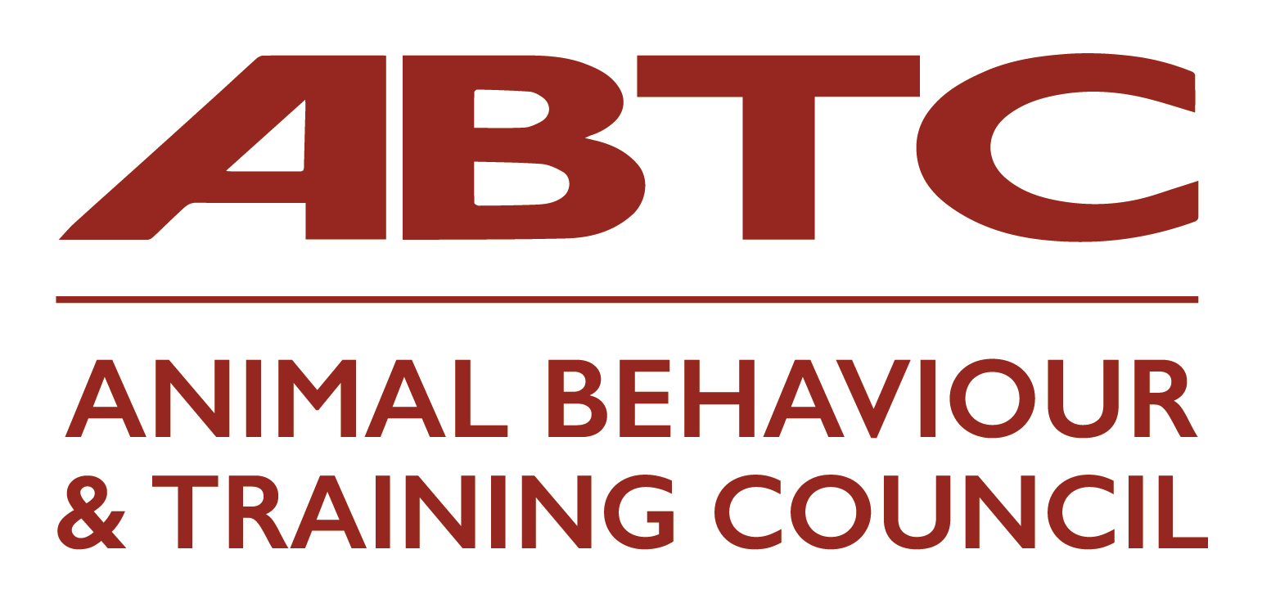
Name of Applicant:
Please refer to the ABTC Guidelines and the ABTC standards prior to completing this form.
Please refer also to the Reflective Accounts Form – one form for each section of Knowledge and Understanding
Overview: ABTC Standard - Clinical Animal Behaviourist
This Standard relates to the clinical application of the science of animal behaviour, and the modification of the behaviour of animals that are demonstrating all types of undesirable, inappropriate, problematic or dangerous behaviour, including those with a potential link to pathologies that require diagnosis in collaboration with a veterinary surgeon.
This Standard involves understanding how to evaluate, prevent or address inappropriate or problematic behaviours within individual animals, through the development of suitable environments and management/treatment regimes that are likely to be effective, based on best practice and scientific evidence. These may be for training rehabilitation or prevention purposes, when caring for the animal or when assisting and advising another person or organisation on undesirable behaviour in their animal/s.
This standard is suitable for those working in the animal care sector, with responsibility for planning and managing humane approaches to the addressing of inappropriate behaviour of animals, and who have an extensive understanding of clinical animal behaviour and the related scientific/clinical literature.
The Veterinary Surgeons Act limits the activities which may be carried out by those who are not registered veterinary surgeons. All activities should be carried out within the constraints of the Veterinary Surgeons Act.
In accordance with the ABTC Code of Professional Conduct, all individual practitioners are required to work within this ABTC Standard and their professional competence. All cases that are or develop beyond the scope of this ABTC Standard should be referred on responsibly (see Code of Professional Conduct section 1.2).
All practitioners should be familiar with the ABTC Standard for their role and that of all other ABTC roles, so that they understand the differences between the roles and refer accordingly.
Knowledge and Understanding | Type of Evidence Submitted* (including Source/Provider if appropriate) | Type of Learning* | Level of Learning* (if known) e.g. 3, 4, 5, 6 or 7 | Date(s) | Reflective Accounts Form No* (one per K & U section)
Animal Behaviour
K1: The ethology of vertebrate animals, including perceptual abilities, maintenance and social behaviours and communication, their function and their motivational basis in the most commonly kept domestic species.
K2: How to recognise, evaluate and report on the behavioural states of the most commonly kept domestic animals and those that most commonly contribute to the caseload of a Clinical Animal Behaviourist, to include signals indicative of key behavioural states such as fear, nervousness, aggression, ill-health, threat-reduction, play and relaxation.
K3: Behavioural ontogeny; to include sensitive periods, socialisation and attachment theory.
K4: The interaction between biological and evolutionary influences and the environment in which an animal is kept, and their roles in the development of behavioural disorders for a range of the most commonly kept domestic animals.
K5: The process of domestication and its effects on the behaviour of animals and the common interactions between animals and humans and how these can contribute to the development of problematic owner/animal relationship, to include animal abuse, abandonment, animal-hoarding.
Animal Health and Welfare
K6: The key ethological, psychological and physiological concepts that underpin animal welfare.
K7: The physiological and behavioural indicators of welfare in vertebrate animals and their limitations and how to use these practically to assess welfare in the commonly kept domestic species.
K8: Welfare considerations in the management and training of animals and in clinical practice.
Animal Learning and Training
K9: The theory of animal learning to include habituation; sensitisation, classical conditioning, operant conditioning, insight and social learning, animal cognition and the concept of consciousness.
K10: The theory underlying learned problem behaviour and training techniques.
K11: The principles and rationale behind the use of the range of behavioural modification techniques, to include systematic desensitisation, counter-conditioning and the use of clickers.
K12: The techniques most appropriate for the treatment of a range of common behavioural disorders and learned problem behaviours, the rationale for their use/application, and the strengths and weaknesses of each.
The Interaction between Health and Behaviour
K13: The functional anatomy and physiology of the vertebrate nervous and endocrine systems and their role in mediating behaviour.
K14: The concept of neural plasticity and the relevance and influence of environmental and genetic factors in the development of the nervous system.
K15: The signs of ill-health and common conditions influencing behaviour and associated veterinary terminology.
K16: The interaction between health and behaviour in vertebrate animals.
K17: The behavioural consequences of medical disorders.
K18: The evidence for and against a medical component contributing to competing explanations of a behaviour.
K19: Psychopharmacology and the mode of action of the major classes of drugs used in clinical animal behaviour, their role and correct application, and constraints and contra-indicators to their use.
K20: The ethics of psychopharmacological intervention and legal position of the Clinical Animal Behaviourist, Veterinary Surgeon and others regarding the diagnosis, prescription and use of drugs and provision of advice.
Clinical Procedures
K21: The range of common behavioural disorders in animals to include phobias, aggression, stereotypies, anxiety related behaviours, and how to identify and critically evaluate contributing factors.
K22:The appropriate application of the principles of ethology and learning theory to the diagnosis and treatment of common problems.
K23: The key principles in human and family psychology, to include attitude theory, processes of inter-personal relationships, grief and bereavement.
K24: The principles of effective counselling and how to apply to facilitate and maintain behavioural change.
K25: The range of effective communication skills, both in the collection of relevant information and provision of advice in face to face or remote consultations and communication via telephone, email, letters and reports with clients and relevant professionals, and how to assess and resolve issues relating to client understanding.
K26: The interactions appropriate in professional relationships and how to apply these in practice.
K27: The common professional, ethical or other issues that need to be considered or may arise before, during and after a consultation; and the action that is appropriate to address these, including an appreciation of the value of further referral.
K28: Methods for gathering and recording information relevant to the diagnosis of a behavioural disorder and how to critically evaluate and appraise it.
K29: The construction and delivery of appropriately structured treatment regimes that are likely to be effective for behavioural disorders identified.
K30: How to identify situations where further action may be necessary, including ways in which compliance with an extended treatment regime may be encouraged.
Law and Ethics
K31: UK and other relevant legislation that relates to the ownership and use of animals and the role and duties of the Clinical Animal Behaviourist, Veterinary Surgeon, paraprofessionals, owners/handlers and others within it; to include the legal implications and duties associated with the provision of advice and professional liability and client confidentiality.
K32: Employment law, health and safety legislation and the UK-GDPR (United Kingdom General Data Protection Regulation); and their implication for the Clinical Animal Behaviourist, their clients and others.
K33:The ethical guidelines relating to the use of animals.

Critical Analysis and Research
K34: How to critically evaluate the quality of research in terms of the methodology, robustness of data gathered and validity of findings and conclusions, from a range of publications and other sources, in order to judge its suitability as evidence on which to base clinical practice.
K35: How to demonstrate understanding of cognitive biases (e.g. availability and confirmation) and their impact on the clinician and clients.
K36: How to use appropriate methods for the assessment of the effectiveness of suitably structured treatment regimes.
*Details in the Applicant Guidance Document

