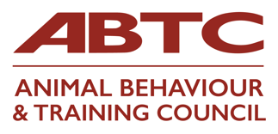

I would like to apply for APEL Assessment via ABTC
Name:
Email:
Telephone number:
Address:
Organisation you are applying to join:
Role applied for: (ABT/CAB)
I have included:
- Mapping document
- Reflective Accounts forms (the number of which may vary for each applicant)
- Any certificates/module descriptors etc. that are referred to in the documentation
- An index to the documents included in my application

Please sign to agree to the below:
I understand that my information will be handled in line with GDPR good practice and that my Practitioner Organisation will retain the documentation for the duration of my provisional/full membership with them.
I understand that my contact details and all information will be shared with the ABTC Assessors
I have read and understand the Guidelines for Applicants
I agree to pay a non-refundable fee of £120 to ABTC for this assessment*
I declare that the information given is a true and honest account of my experience

Signed
Date
*Non-refundable payment of £120 should be sent, via bacs, to:
Animal Behaviour & Training Council
Sort code: 30-92-79
Account no. 28617368

Reference via BACS should be your name and APEL
Please also email admin@abtc.org.uk to let Val know you have paid. She will acknowledge receipt when it arrives in the account.

For office use only:
Date received:
Assessors allocated:
Additional interview:
Result:

