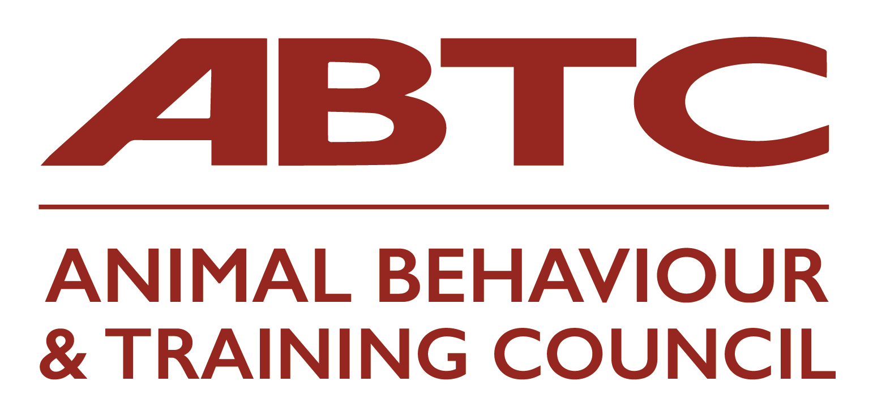
I would like to apply for APEL (Assessment of Prior Experience and/or Learning) Assessment by ABTC
Name:
Email:
Telephone number:
Address:
Assessing Organisation you are applying to join through which your APEL Application will be administered:
Role applied for: Animal Behaviour Technician / Clinical Animal Behaviourist
I have included:
- Mapping document
- Reflective Accounts forms – at least one form is required for each section of the prerequisite Knowledge & Understanding (see below)
- Any certificates/module descriptors etc. that are referred to in the documentation
- An index to the documents included in my application
- Any information which you would like to share with assessors, regarding any particular assessment support or needs you may have
Please sign to agree to the below:
I understand that my information will be handled in line with GDPR good practice and that my Assessing Membership Organisation, and the ABTC, will retain the documentation for the duration of my membership.
I understand that my contact details and all information will be shared with the ABTC Assessors who have signed confidentiality agreements.
I have read and understand the Guidelines for Applicants.
I have paid a non-refundable fee of £120 to ABTC for this assessment and certification.
I have provided my APEL documents to my Assessing Membership Organisation, to be used by the ABTC for Assessment and Certification. I declare that the information given is a true and honest account of my experience.
I understand that I will first be assessed on my written evidence and that if my written evidence does not demonstrate that all of the K&U have been met, my assessors will make a decision on whether an interview would be beneficial for me to be able to fully demonstrate my competence.

Signed
Date
*Non-refundable payment of £120 should be sent, via bacs, to:
Animal Behaviour & Training Council
Sort code: 30-92-79
Account no. 28617368

Reference on the bacs should be your name and ‘APEL’
Please also email assessments@abtc.org.uk to let Helen know you have paid. She will acknowledge receipt when it arrives in the account.

You will have been notified if your organisation also has an admin fee. The requirement for any admin fee should be made clear by your Assessing Membership Organisation.

For office use only:
Date received:
Payment received:
Assessors allocated:
Additional interview:
Result:

Knowledge & Understanding (K&U) Sections for Reflective Accounts Forms (see above)
Animal Behaviour Technician | Clinical Animal Behaviourist
Animal Behaviour | Animal Behaviour
Animal Health and Welfare | Animal Health and Welfare
Animal Learning and Training | Animal Learning and Training
The Interaction between Health and Behaviour | The Interaction between Health and Behaviour
Clinical Procedures | Clinical Procedures
 | Law and Ethics
 | Critical Analysis and Research

