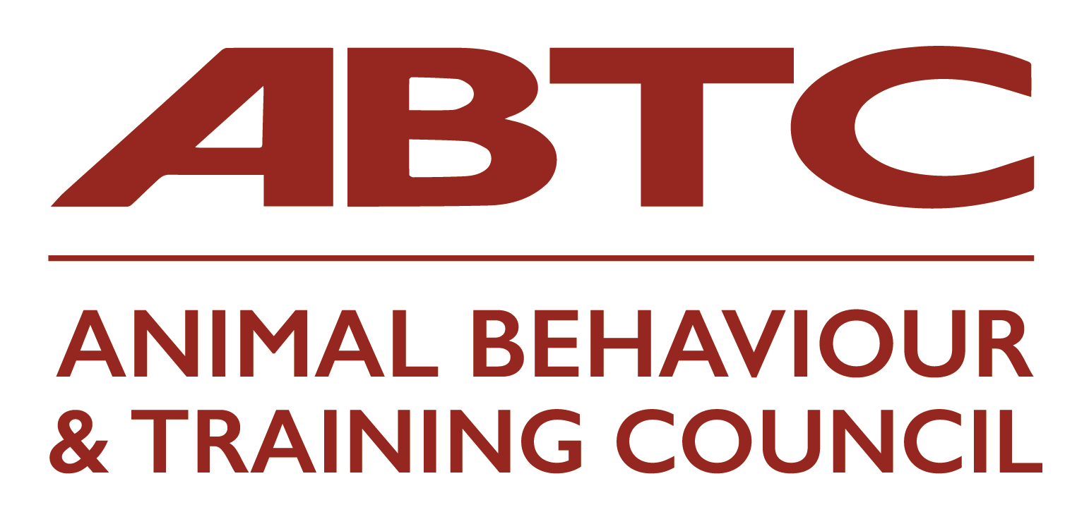
APEL Reflective Accounts Form (for ABT and CAB roles)

Please use this form to record written reflective accounts on all learning and training that you are submitting for APEL and how it relates to the Knowledge & Understanding (e.g. Animal Health and Welfare) sections of the standards. This is set out in the APEL Guidelines, as evidence types A, B, C, and D.

Please be aware that specific examples - and detail - in response to the questions below will allow you to demonstrate your knowledge and understanding much more clearly for Assessors than generic statements.

Use one form for each Knowledge & Understanding section, making sure you do not include any information that might identify a specific client, service user, colleague or other individuals.

Name:
Knowledge section/ Knowledge & Understanding number(s):
What was the nature of the learning?
Why did you choose to undertake this learning?
How is your learning relevant to the Knowledge & Understanding?
Briefly provide specific examples of how this learning demonstrates your Knowledge & Understanding
How did this Knowledge & Understanding change or improve your practice? Please ensure you provide examples/detail to support your answers.

